
ST ANDREW’S JUNIOR COLLEGE
Preliminary Examinations
Higher 2

H2 Geography 9173/01
Paper 1 28 August 2025
INSERT 3 hours

READ THESE INSTRUCTIONS FIRST

This insert contains all the Resources referred to in the questions.

This document consists of 7 printed pages.

[Turn over
Resource 1 for Question 1

Top 5 exporters of cocoa and their total export value

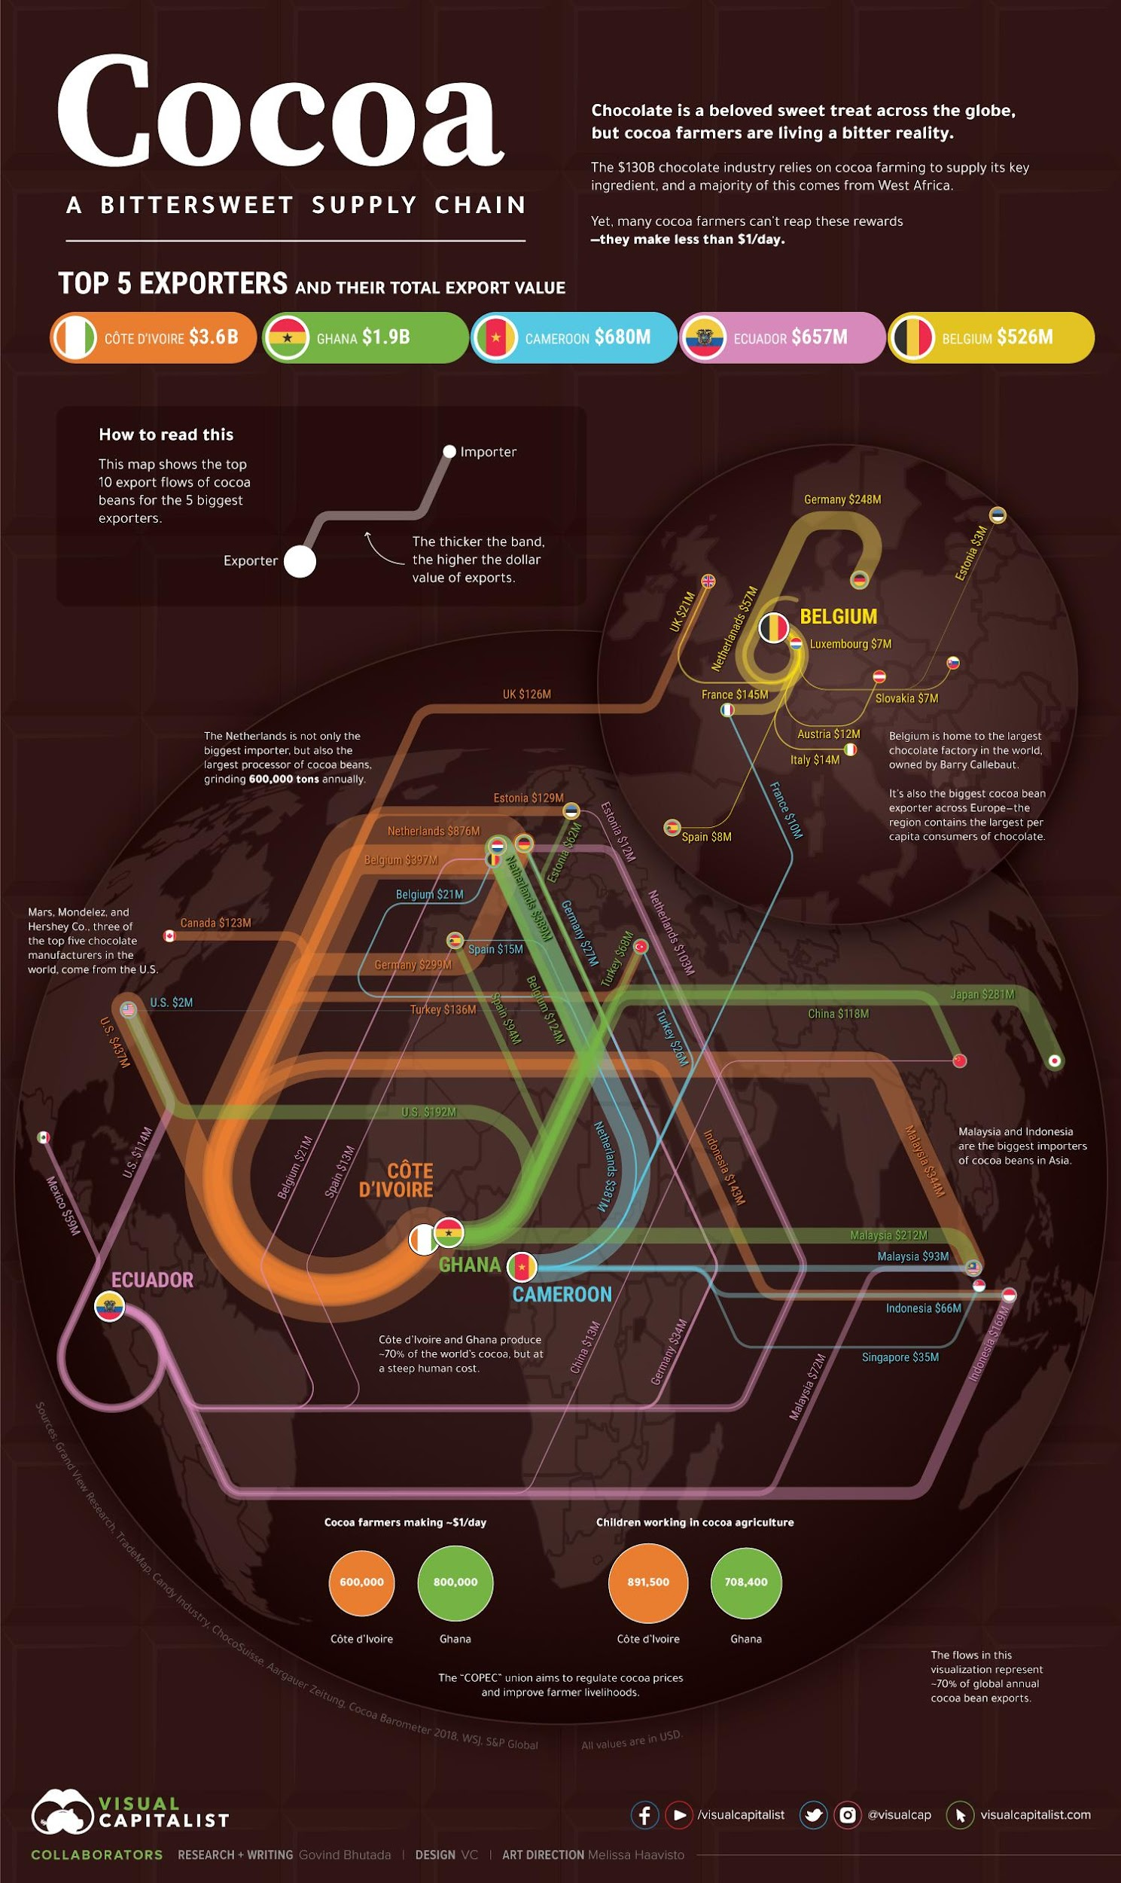
How to read this

This map shows the top
10 export flows of cocoa beans for the 5 biggest exporters.
The thicker the band, the higher the dollar value of exports.
Belgium is home to the largest chocolate factory in the world, owned by Barry Callebaut.

It’s also the biggest cocoa bean exporter across Europe – the region contains the largest per capita consumers of chocolate.
The “COPEC” union aims to regulate cocoa prices and improve farmers livelihoods.
Cote d’Ivoire Ghana Cote d’Ivoire Ghana
Cote d’Ivoire and Ghana produce 70% of the world’s cocoa, but at a steep human cost.
The flows in this visualization represent 70% of global annual cocoa bean exports.
Mars, Mondelez and Hershey Co., three of the top five chocolate manufacturers in the world, come from the U.S.
The Netherlands is not only the biggest importer, but also the largest processor of cocoa beans, grinding 600,000 tons annually.
Malaysia and Indonesia are the biggest importers of cocoa beans in Asia.
Cocoa farmers making $1/day
Children working in cocoa agriculture
Importer
Exporter
The $130B chocolate industry relies on cocoa farming to supply its key ingredient, and a majority of this comes from West Africa.

Yet, many cocoa farmers can’t reap these rewards
-they make less than $1/day.
Resource 2 for Question 1

Information about cocoa cultivation

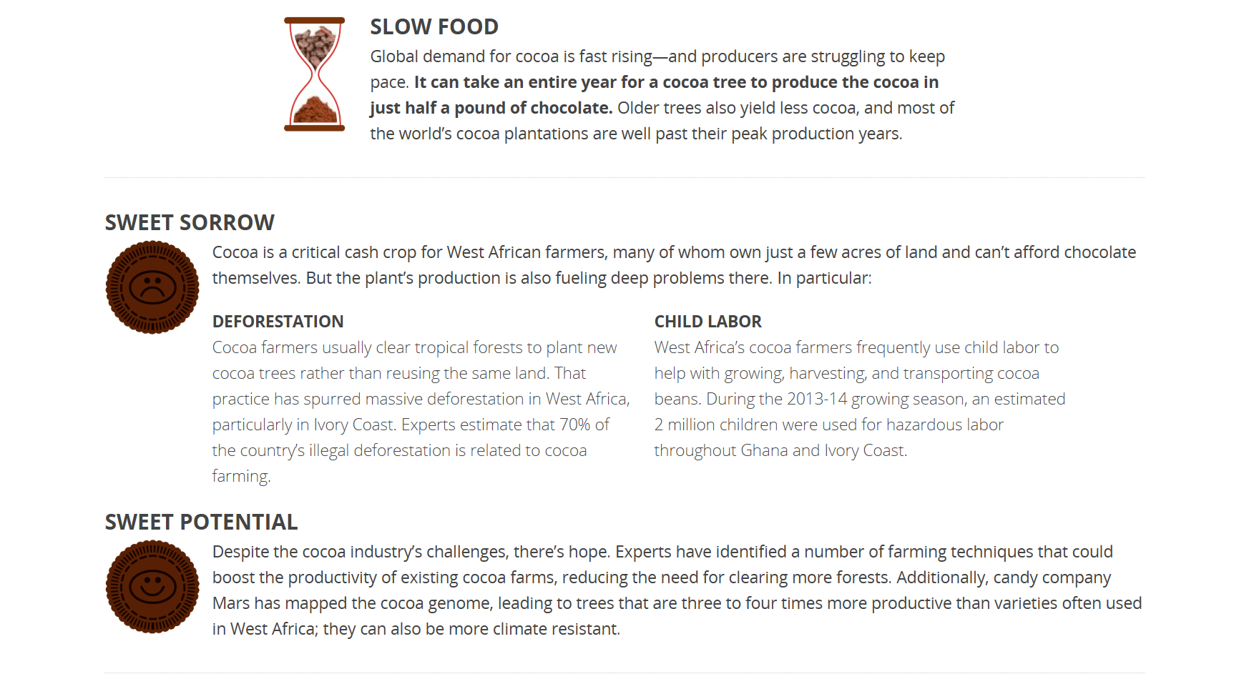
Cocoa farmers usually clear tropical forests to plant new cocoa trees rather than reusing the same land. That practice has spurred massive deforestation in West Africa, particularly in Ivory Coast. Experts estimate that 70% of the country’s illegal deforestation is related to cocoa farming.
West Africa’s cocoa farmers frequently use child labour to help with growing, harvesting, and transporting cocoa beans. During the 2013-14 growing season, an estimated 2 million children were used for hazardous labour throughout Ghana and Ivory Coast.

Resource 3 for Question 1

Impact of climate change on cocoa production

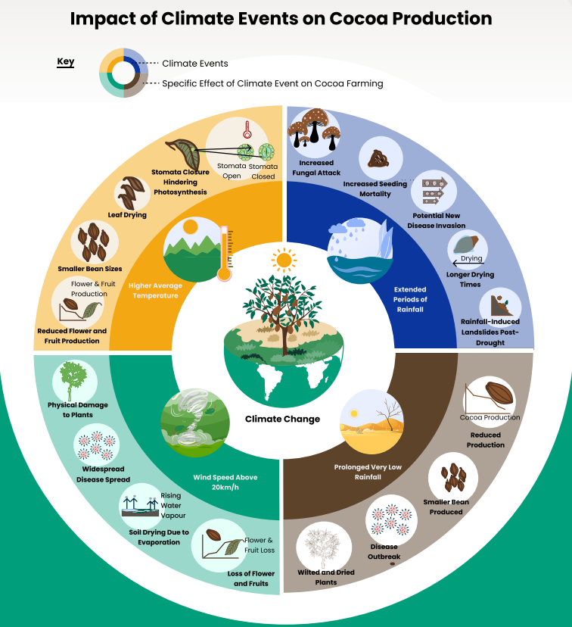
[Turn over

Resource 4 for Question 2  Climograph of Mangalore, India  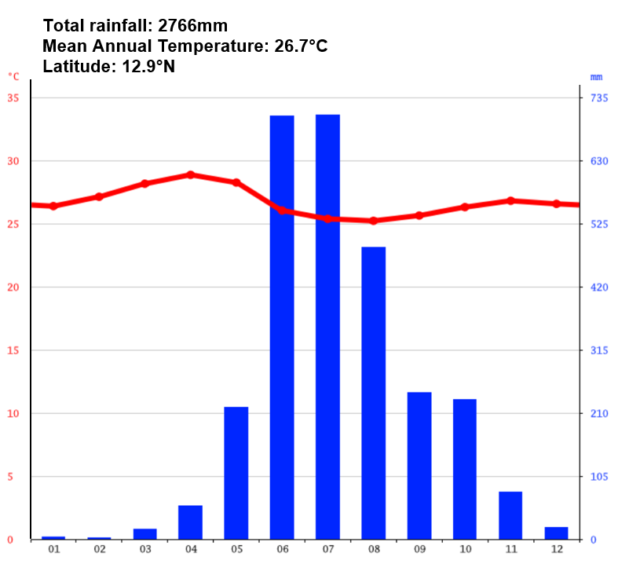  Months  Rainfall  Temperature | Resource 5 for Question 2  Arrival of monsoon winds in India  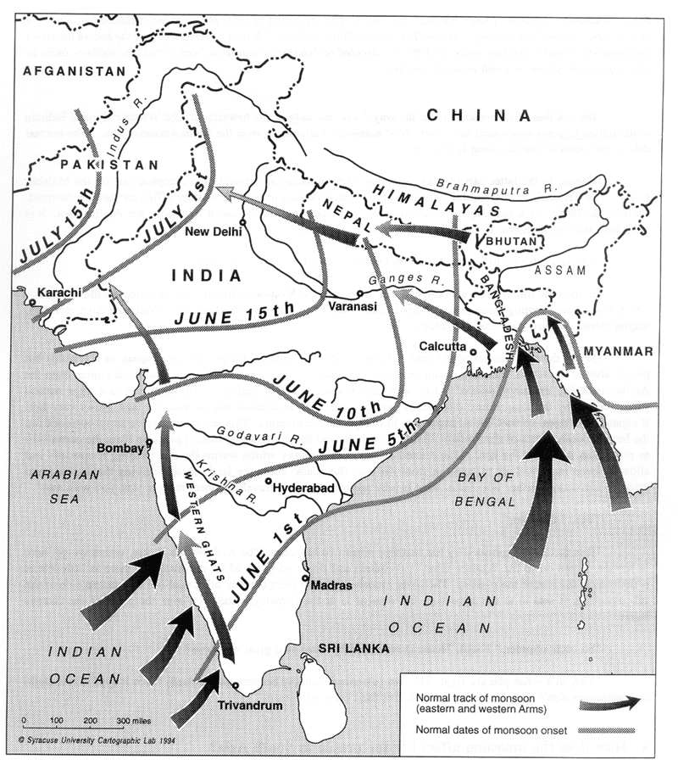

Resource 6 for Question 2

Seasonal monsoon wind system in India
JUNE - JULY
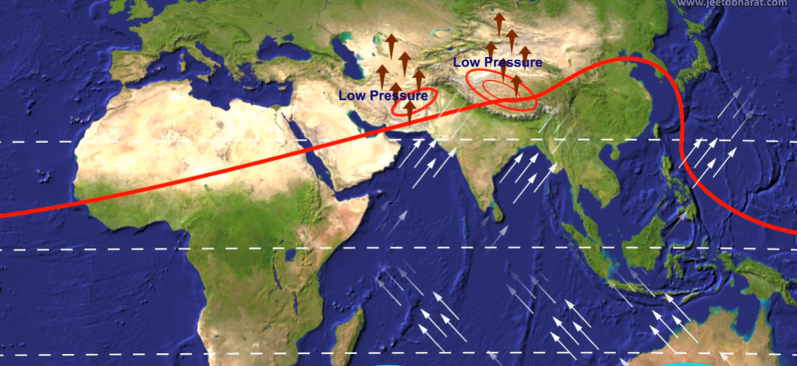

Equator
Tropic of Cancer
Tropic of Capricorn

DECEMBER - JANUARY
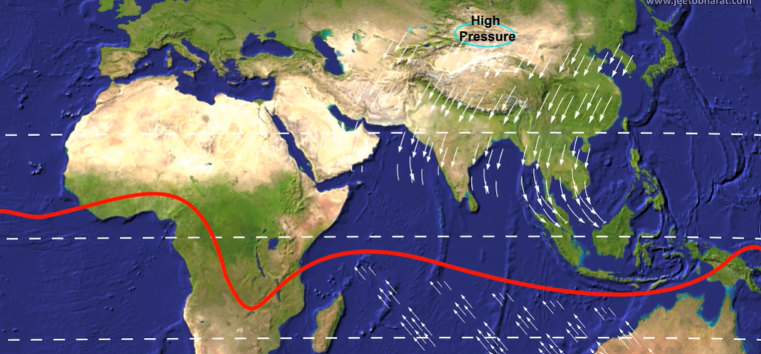

Tropic of Cancer
Tropic of Capricorn
Equator

Mangalore, India

Inter Tropical Convergence Zone

Resource 7 for Question 2

Hydrograph recorded after an intense rainfall event that occurred in June

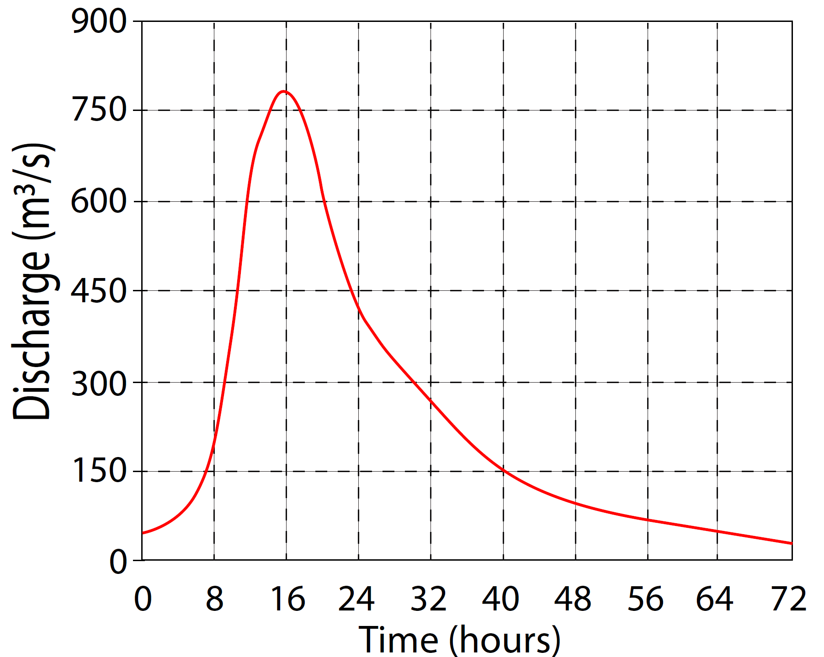

0
50
100
Rainfall in mm

